**University of Barishal**



**Report about: why should a student learn computers?**

**Instructed by**

Dr.tania islam

Dpt of CSE

University of barishal

**Submitted by**

Khadija akter esha

Roll :23

Batch :47

**Introduction:**

Learning about computers is an exciting journey that opens up a world of possibilities. Computers are electronic devices that process and store information, and they are a cornerstone of modern technology. Understanding how they work and how to use them effectively is essential in today’s digital age.

**What is Learning About Computers?**

Learning about computers involves understanding:

1. **Hardware**: The physical components of a computer (e.g., CPU, RAM, hard drive, motherboard, and peripherals like the keyboard and mouse).
2. **Software**: The programs and operating systems that enable a computer to perform tasks.
3. **Basic Operations**: Using a computer to perform common tasks like typing, browsing the internet, or managing files.
4. **Programming**: Writing instructions in a language that a computer understands to create applications or automate tasks.
5. **Networking**: Understanding how computers communicate with each other via networks, including the internet.

**Why Learn About Computers?**

* **Daily Life**: Computers are used in education, communication, entertainment, and more.
* **Workplace Skills**: Proficiency with computers is essential in almost every profession.
* **Problem-Solving**: Computers can be tools for solving complex problems efficiently.
* **Innovation**: Learning about computers can spark creativity, leading to new inventions and technologies.

**Benefits of Computer Literacy**

* Enhanced productivity and efficiency.
* Access to vast information and resources.
* Opportunities for learning, career advancement, and innovation.

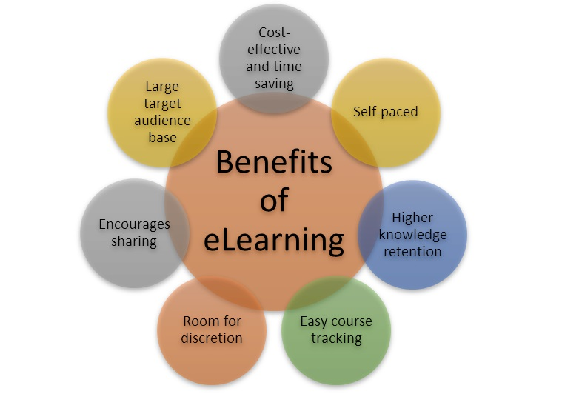

**Importance of learning computer for a students**

**1. Enhances Learning and Education**

* Access to Information
* Interactive Learning
* Research Skills

**2. Develops Essential Life Skills**

* Digital Literacy
* Problem-Solving
* Communication

**3. Prepares for Future Careers**

* Job Readiness
* Technology Integration
* Competitive Edge

**4. Encourages Creativity and Innovation**

* Creative Tools
* Coding and Development
* Entrepreneurial Skills

**5. Supports Personal Growth**

* Time Management
* Collaboration
* Global Perspective

### ****6. Future-Proofing Education****

As technology continues to advance, students who are adept at using computers will be better equipped to adapt to changes, stay relevant, and thrive in a technology-driven society.

**How many type of computer learning systems are there in Barishal university?**

3 type of computer systems are present in barishal university

* Basic fundamental
* Python
* Web development
* Data base

Basic fundamental: to know basic function ,like,ppt ,word ,Excel,etc

Python : to know computer programming language

Web development :to know web page development ,web deign ,web sheet create etc

**Data base :**solving problem of data base

**Percentage**

A table about 47 batch student and their performance in basic fundamental

|  |  |  |  |
| --- | --- | --- | --- |
| **Student name** | **Pptx%** | **Word file %** | **Excel %** |
| Nabila | 98 | 87 | 60 |
| ira | 97 | 88 | 66 |
| Tania | 96 | 81 | 68 |
| maisha | 95 | 82 | 67 |
| samiha | 99 | 83 | 61 |

**Conclusion**

In short, learning computers equips students with skills that are not just useful but essential in navigating the modern world, academically, professionally, and personally.